<https://codersinn.site/Med-market/public/register>

alert messages like **\*Please enter your first name.**

[**I Agree to Terms and Conditions**](https://codersinn.site/Med-market/public/terms-condition) **– going to wrong page**

**OTP page to verify phone number** – text alignment issues – **OTP page**

**My Buyer Dashboard** - Quick **Links** - Wishlist/Saved Items - Chat - Messages

Help & **Contact** - Contact Administrator - **all will be in red color**

**CHAT PAGE -** 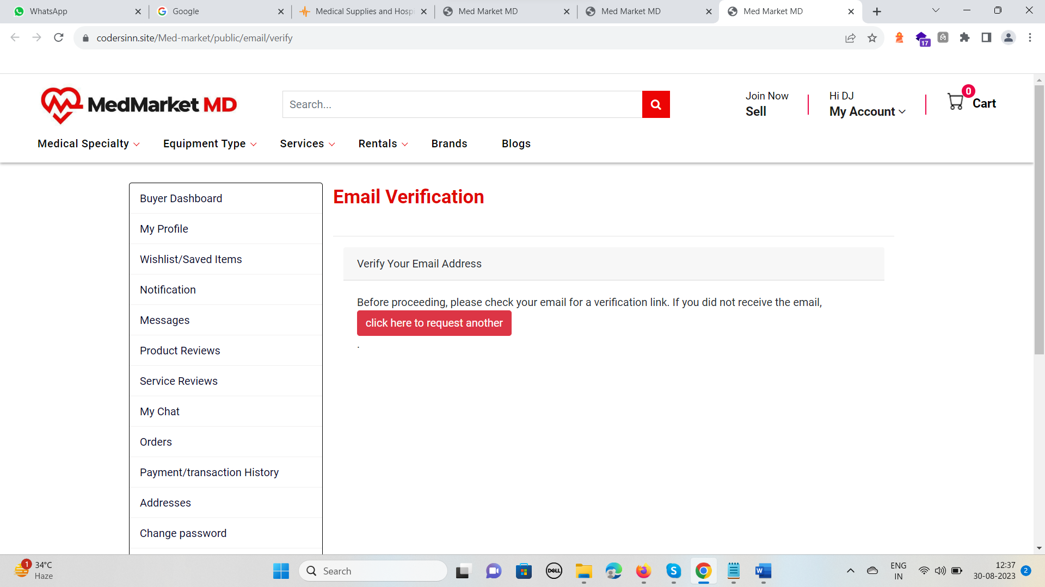 C in caps of CLICK, all pages

**Left menu changes position, WHY** - 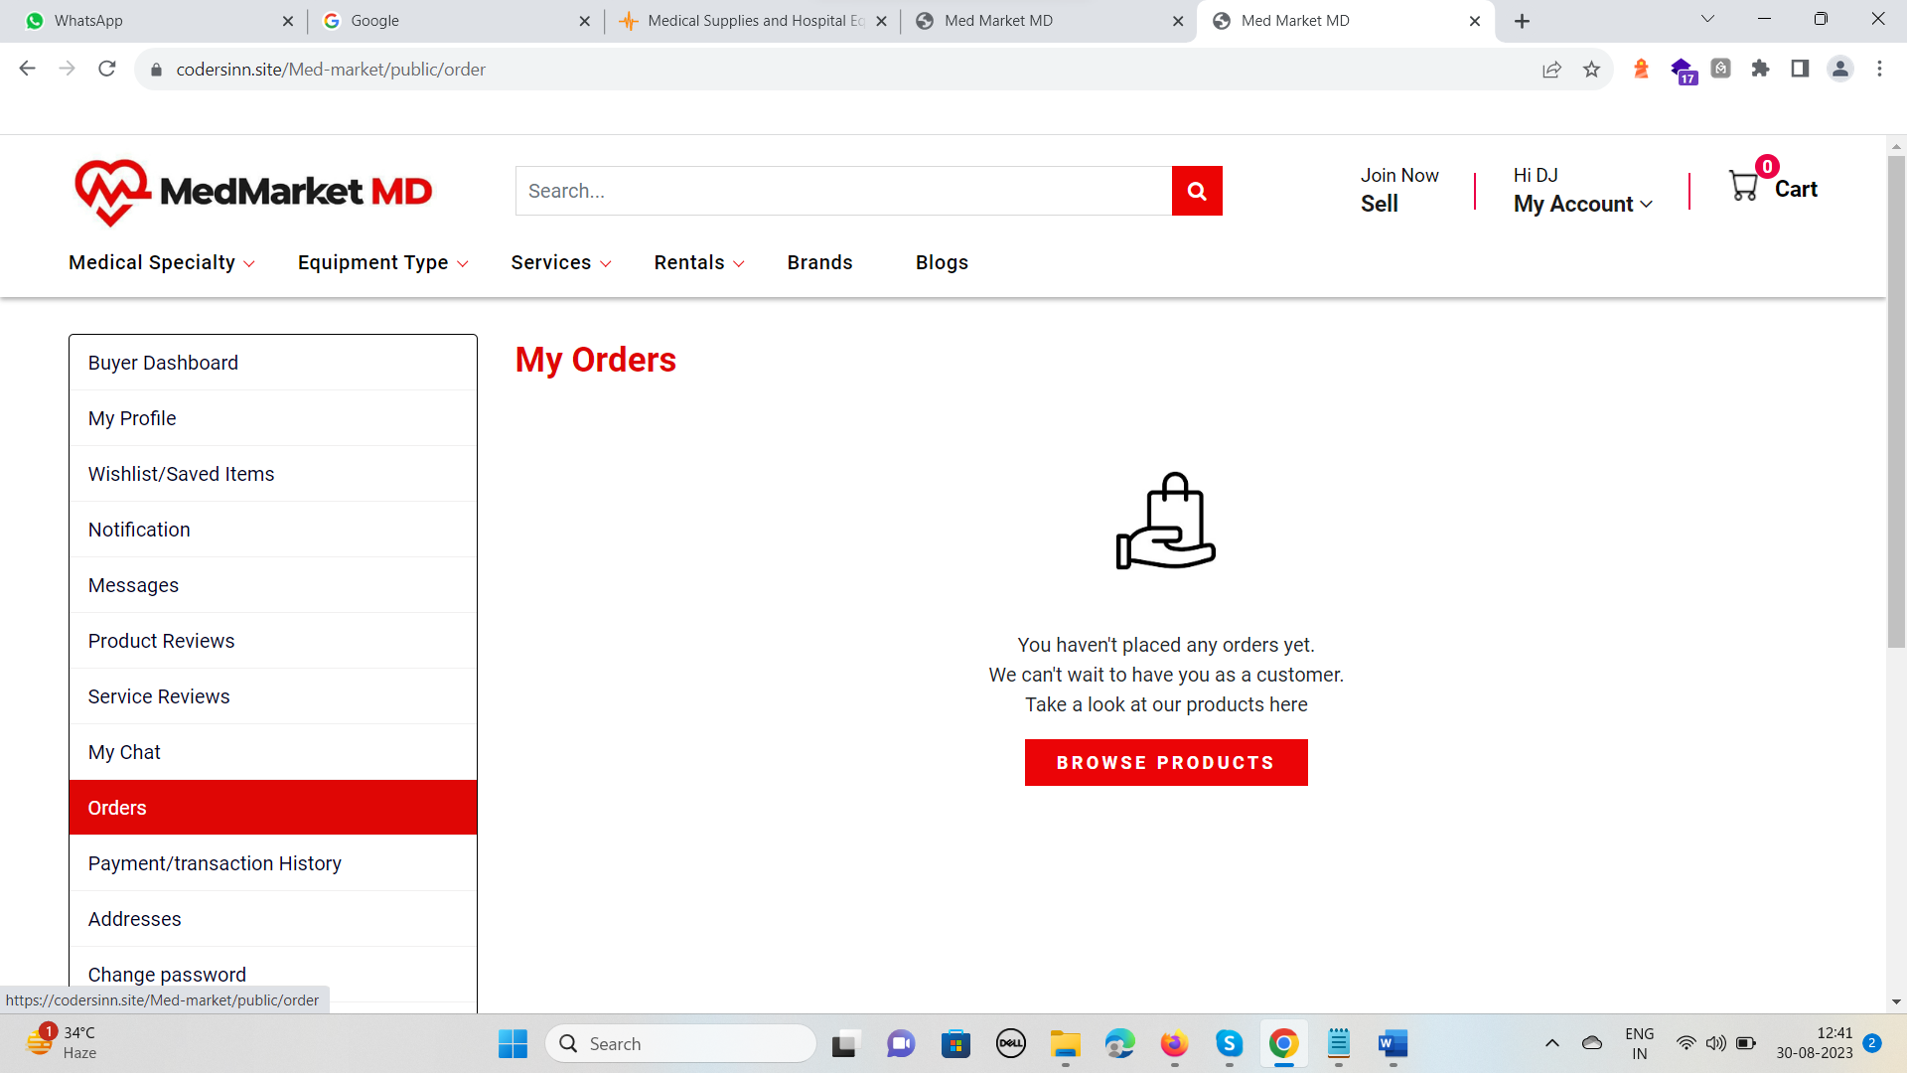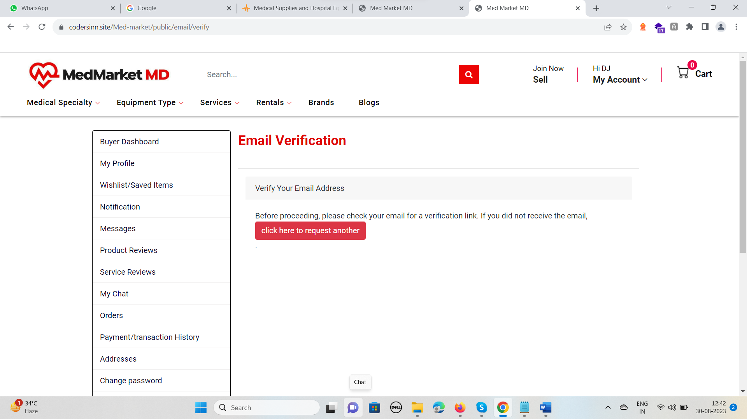 when email is not verified it keeps changing position from left…

**Profile Image** – will have a user icon dummy, now its blank at first and when u add and delete images it comes up …

**WISHLIST –** heading will be Product**s** and button will be - BROWSE RENTAL**S**

Unable to remove ads from wishlist in rentals section

**Messages -** Welcome, to your MedMarket MD Inbox.

You have no messages at this time

When is **NOTIFICATIONS** working,, as it does not show up in case of CHAT, messages etc. on dashboard and noti’s page

**My Chat** – loads late and shows icon first of - No chats at this time – it should not come when user is having chats in it… no user image coming …. Green dot on wrong side

Form chat page when u click on name Vijay or AD name it takes you to new error page 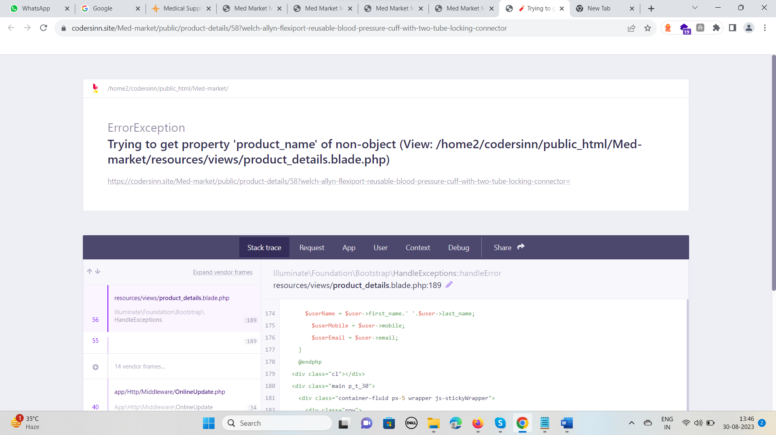

Chat Ui error in firefox 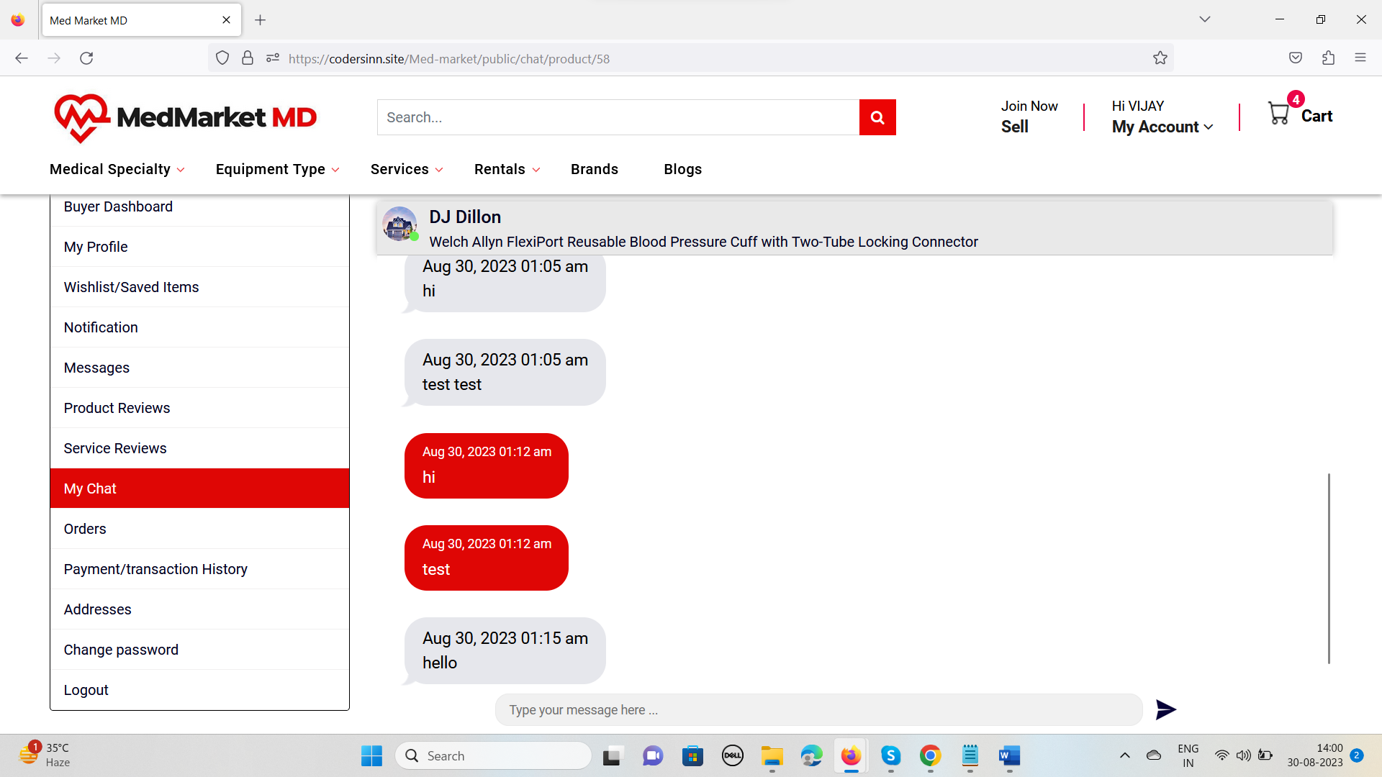

Heading on page will be **Product Reviews –** Ad title will be clickable

Service Reviews – will say **BROWSE SERVICES**

**Just to mention don’t forget admin can manage all reviews from admin panel and delete them as well**

**Add Address** – Make it default address is missing …. All fields will have dark black border when selected now its blue

ZIP Code – error why its asking to add 6 characters min…

When u click on EDIT address if billing was checked it will come checked on editing and change color on UPDATE from blue to out theme color

No error message come on when name or anything is not entered..

When ORDER is placed 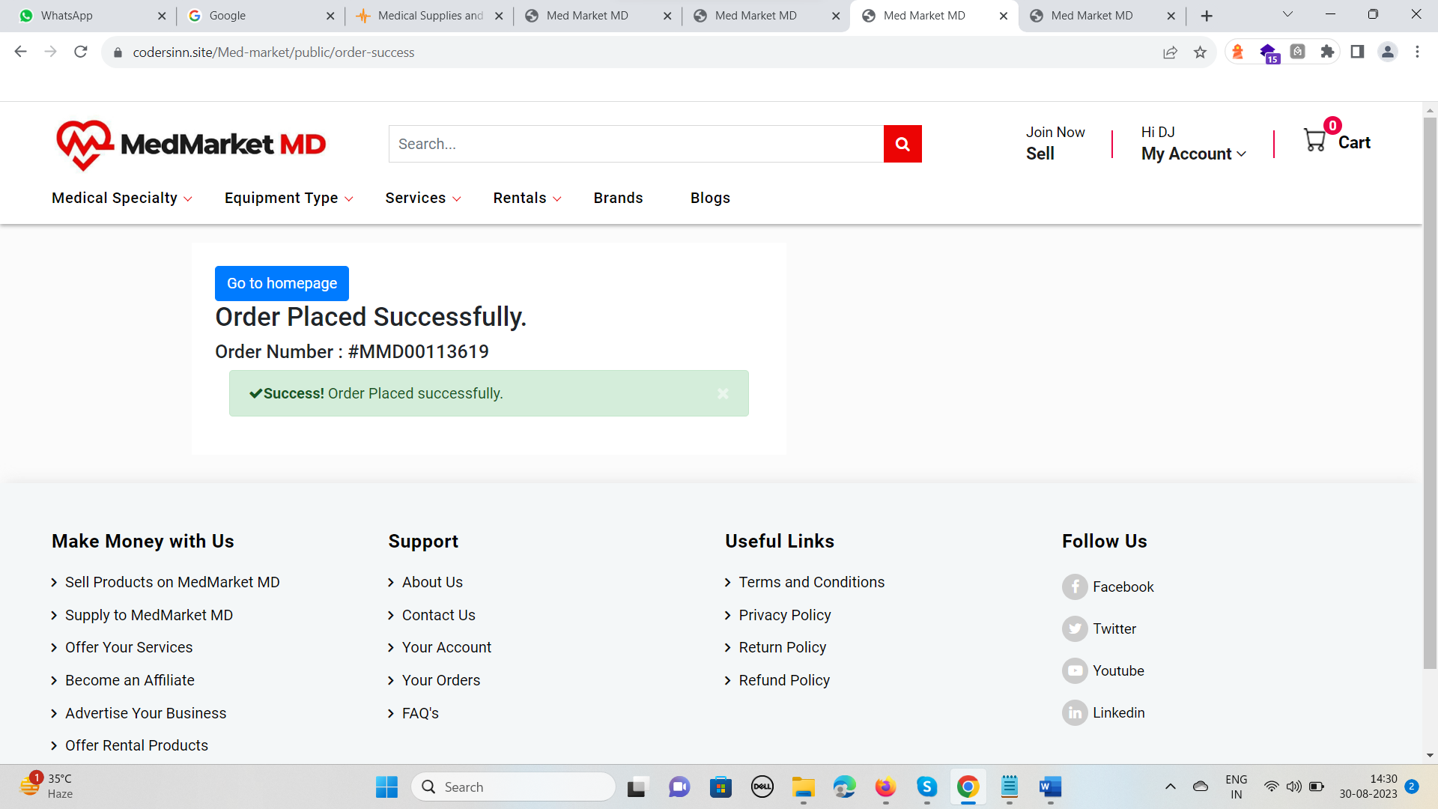 go to homepage will be in red color and will say Go to Orders Page OR **View Your Order**

**ORDERS** – date format will be corrected, ADDRESS will have spaces after every comma , for city state country etc…. Make BACK a button …. When order is cancelled BACK button does not work…. TAX and shipping info will be added once provided by client

**Payment / Transaction History** – date format, Download Invoice will be added once user will provide details

**Change Password** - fields border will be in black like forms and

**BECOME A SELLER** - 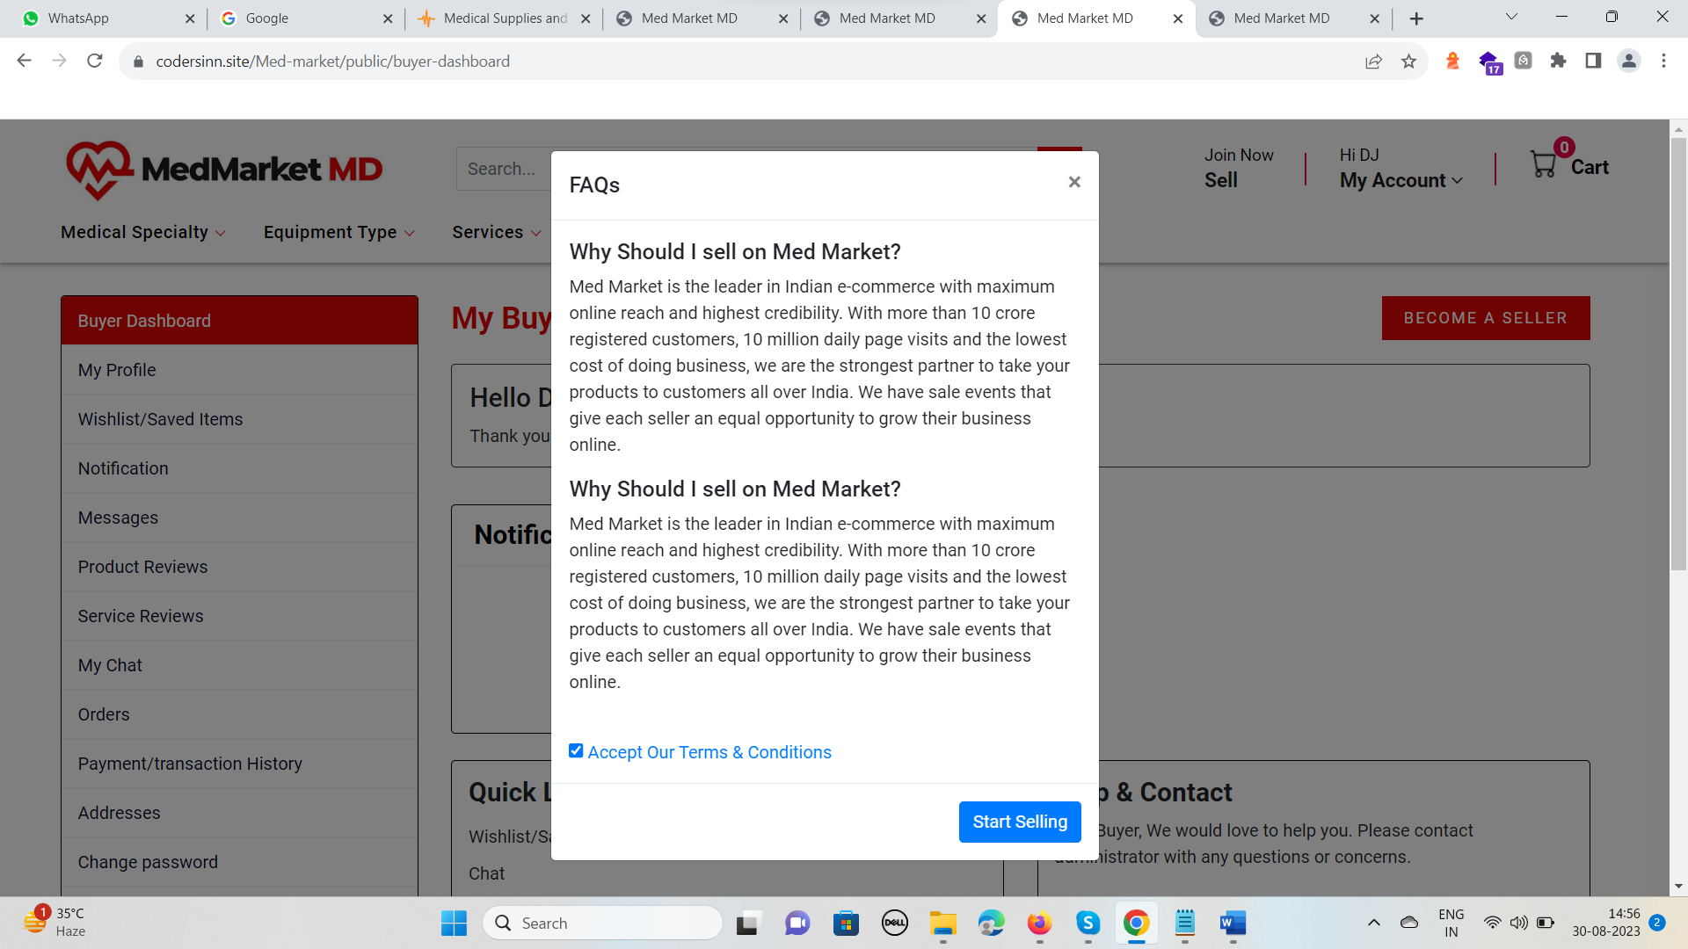 and everything will be in black and red – content needs to be updated

After clicking START selling it will go to SELLER Dashboard

**SELLER dashboard** - Become a Featured Seller – It – it will start with i in caps …

**SELLER PROFILE** - 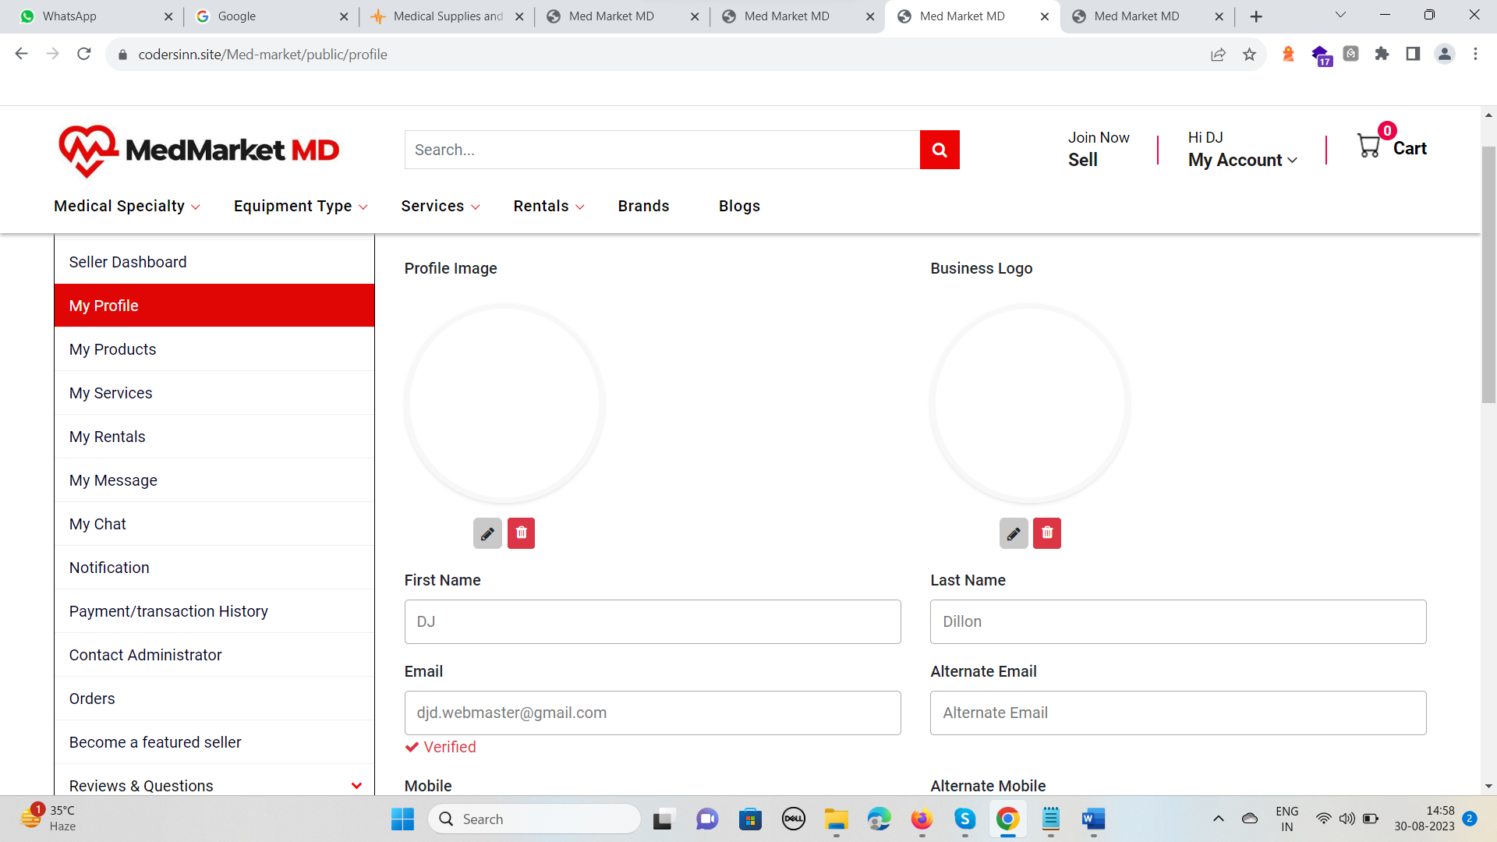 both icons are blank and please choose a better icon else I’ll provide you let me know and update it in **BUYER** dashboard profile page too

**SAVE and CANCEL** both saving which is wrong … No Alerts messages coming… ZIP code will not have any condition in whole website

My Listing - **My Products Ads -**  + sign and image will be like RENTALS and content will be

**You have not added any products in**

**your products list. Click to create Product Ad.**

**View All** in case of many sub cats after 2 rows… $ sign will not come until price is added ….

**Search Bar** not working

**Product Form** – Spacing issue with **Medical Speciality** – Select category and other headings will never scroll and will be sticky and increase height of these boxes. Above TITLE add more space

When you remove any category, its sub-cats will also be removed and now it stays there and never gets removed – sub-cats

Description * - filed will be black border when selected

SUCCESSFULLY saved as draft pop-up is not working and will hold there and will have back or red button.

When image is added and you accidentally delete it, you will not be able to add same image until you add any other image….

Cross icon for **KEY FEATURES** not aligned in centre

**Space in ROWS** when TAGS are in 2 rows

While editing drafted AD Brand does not give **OTHER** option

CONFIGURATION/CERTIFIED/CERTIFICATION - **cross icon in center** while editing AD, there will be no character limit else it gives error

COMPANY/PRODUCT DOC – **space issue** in between fields while editing AD, cross icon like other fields, now in RED box

**Portable** - when selected YES new field goes up - alignment issue

You have not added any rental ads in

your rentals list. Click to create rental Ad.

My Buyer Dashboard

Shipping / order status will be changed / updated from order details page and with an option of reversing it and also it will have option to add shipping carrier name and tracking details